Bird Study Unit Summary 3rd Grade

Introductory Lesson
Question(s) | Phenomenon | Scientific Practice(s) | What We Figured Out  DC I- CCCs | Learning goals  (Learning Performances)
1. What is the Red Winged Blackbird’s epaulet FOR? | The male red-winged blackbird has a bright red and yellow epaulet | Asking questions and constructing and analyzing claims based on evidence. | LS4-2 Differences among the individual bird’s features can help them survive, find a mate, or reproduce.  “The red-winged black bird’s _____ helps it survive because…  “The red-winged black bird’s epaulet helps it survive because… I know this because…  ccc. cause and effect  ccc. patterns | Student will ask and answer questions about specific physical features of the RBB and engage in argument with evidence about how these would help them survive, find mates, and reproduce.

Bird Study Lesson One
Question(s) | Phenomenon | Scientific Practice(s) | What We Figured Out  (DCI) - (CCC) | Learning goals  (Learning Performances)
2. Can we predict what the RWBB do on the cattail (branch, etc)?  subQ:  How do we verify/investigate our claims about what the epaulet is for? | Red Winged Blackbirds act really bizarre and have interesting calls and stances. | Plan and conduct an investigation | TS1.B: Developing Possible Solutions  Research on a problem should be carried out before beginning to design a solution. Testing a solution involves investigating how well it performs under a range of likely conditions.  “We can make predictions and test them with observations to help us choose which claim to look at more closely. “  ccc. cause and effect | Students will predict possible observable behaviors of the RWBB that will verify or eliminate certain claims.

Field Trip: Lesson Two and Follow-up
Question(s) | Phenomenon | Scientific Practice(s) | What We Figured Out  (DCI) - (CCC) | Learning goals  (Learning Performances)
3. What do we observe in the RWBB’s behavior and habitat? | The wetland landscape is varied and diverse. | Plan and conduct an investigation | TS1.B: Developing Possible Solutions  Make observations and/or measurements to produce data to serve as the basis for evidence for an explanation of a phenomenon or test a design solution. (3-PS2-2)  “The RWBB’s behavior and habitat can help us answer and evaluate questions and claims.”  ccc.scale,proportion and quantity | Students will collect data about behavior and the habitat of the RWBB while on a field trip in a wetland.
Follow-up  Questions:  What do our observations tell us? | Red-winged blackbirds take territorial stances in their environment. | Analyze and interpret data.  Make a claim about the merit of a solution to a problem | “Based on what we observed, some of our claims can be adjusted, discarded, or added” | Students create explanations based on their collected evidence about how animal behavior affects survival based on evidence and prior knowledge

Lesson Three: Incorporating New Information
Question(s) | Phenomenon | Scientific Practice(s) | What We Figured Out  (DCI) - (CCC) | Learning goals  (Learning Performances)
4. What happens if we blacken the epaulet? | When RWBB’s epaulet is blackened, it loses its territory. | 3-EESS2-2 Obtain and combine information | LS4-2 Differences among the individual bird’s behavior can help them survive, find a mate, or reproduce.  We found that the epaulet is related to the territory of the RWBB.  ccc. cause and effect  CNS. Science Models, Laws, Mechanisms, Theories Explain Natural Phenomena: Science explanations can change based on new evidence | Students will incorporate new information from a published scientific study to their claims; that scientists have discovered that when a RWBB’s epaulet is blackened, it loses its territory.

Lesson Four: Features of the Wetland
Question(s) | Phenomenon | Scientific Practice(s) | What We Figured Out  (DCI) - (CCC) | Learning goals  (Learning Performances)
5. Are some areas of the wetland better for building a nest than others? | The RRBB builds more nests in certain areas of the wetland than others. | Make observations and collect evidence  Analyzing data  Constructing claims | LS4-3 The particular habitat helps more red-winged blackbirds to be able to build nests than other kinds of birds.  “Area ___ would be/is better for the red-winged Blackbird to build a nest because it contains more things the RRBB needs.“  ccc. cause and effect | Students will collect data of the different features of the wetland and explain that the different features of the wetland would or would not meet the needs of the mother bird and her young.

Lesson Five: Does Better Territory Mean More Eggs?
Question(s) | Phenomenon | Scientific Practice(s) | What We Figured Out  (DCI) - (CCC) | Learning goals  (Learning Performances)
Does better territory mean more eggs? | In certain parts of the wetland, there were more birds and more nests. | represent data in tables and graphical displays | LS4-2 Differences in the territory of the RWBB can help them reproduce.  “Area _____ was better for nests. It had an average of _____ more eggs than area _____. “  ccc. cause and effect | Students will create a graph of nests in chosen areas and tabulate the average number of eggs for each territory.

Lesson Six: Summative Assessment (Engineering)
Question(s) | Phenomenon | Scientific Practice(s) | What We Figured Out  (DCI) - (CCC) | Learning goals  (Learning Performances)
6.How can we design a solution for ourselves that would work like an epaulet and warn others when we want to be alone but can also change to show others that we ‘are friendly and want to play? | Red-winged blackbirds sometimes fly and look for food in groups. | design solutions | LS2-1 The RWBB challenges birds sometimes for food, land, or mates, but at other times needs to be in a group. He changes his behavior for these two situations. His epaulet is designed to show whether he wants to work in a group or challenge others.  ccc. cause and effect | Students will construct model for themselves that will mimic an epaulet to show that they are ready to work or play in a group or not.  Students will witness the natural design of the RWBB and compare it with their own designs.

Driving Question (DQ) from Framework: How does genetic variation among organisms affect survival and reproduction?

Driving Question (DQ) of Unit: How do differences within bird species help them survive and reproduce?

Initial Driving Question (DQ) for Sparking Students’ Attention/discussion About Behavior of RWBB: Did you ever wonder what the Red Winged Blackbird's epaulet FOR?

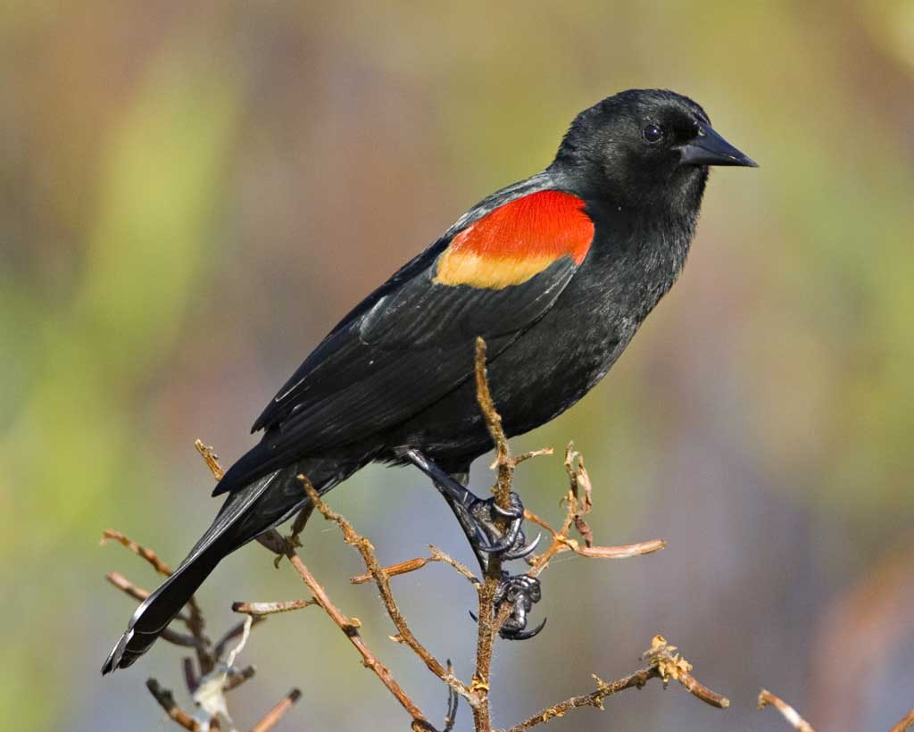

DCI related to this unit: LS4.B: Natural selection: Sometimes the differences in characteristics between individuals of the same species provide advantages in surviving, finding mates, and reproducing.

Unit Objective: Students will use evidence to construct an explanation for how the variations in characteristics among individuals of the same species may provide advantages in surviving, finding mates, and reproducing.

Final Claim (This will vary from class to class).

The male RWBB is displaying his epaulet because so that it doesn’t lose its territory and it wants the best territory for making nests and having chicks. The best territory has high grass so the nest can be hidden with only a few trees so the bird can spot danger from far away and water nearby so there is a lot of bugs my evidence is…scientists from Stanford found that when they blackened the epaulets, most of these birds lost their territory. And birds with the best territory have more nests and more eggs.This is like other animals because when bears show their teeth, they warn other bears to stay away.
When RWBBs need to work in groups to survive, they cover up their epaulets with a piece of black feather.

